

Dissertation on

“Generative AI in marketing”

Submitted in partial fulfillment of the requirements for the award of the degree
of
Bachelor of Technology
in
Computer Science & Engineering

UE22CS320A – Capstone Project Phase - 1

Submitted by:

Hrishita Patra  Srishti Mathur  Suhani Verma  Dhruva R Prasad | PES1UG22CS241  PES1UG22CS614  PES1UG22CS623  PES1UG22CS186

Under the guidance of

Dr. Shylaja S.S
Director of Cloud Computing & Big Data (CCBD), Centre for Data Sciences & Applied Machine Learning (CDSAML)
PES University

August - December 2024

DEPARTMENT OF COMPUTER SCIENCE AND ENGINEERING
FACULTY OF ENGINEERING
PES UNIVERSITY

(Established under Karnataka Act No. 16 of 2013)

100 feet Ring road, BSK 3rd stage, Hosakerehalli, Bengaluru – 560085



PES UNIVERSITY

(Established under Karnataka Act No. 16 of 2013)
100ft Ring Road, Bengaluru – 560 085, Karnataka, India

FACULTY OF ENGINEERING

CERTIFICATE

This is to certify that the dissertation entitled

‘Generative AI in marketing’

is a bonafide work carried out by

Hrishita Patra  Srishti Mathur  Suhani Verma  Dhruva R Prasad | PES1UG22CS241  PES1UG22CS614  PES1UG22CS623  PES1UG22CS186

In partial fulfillment for the completion of Fifth-semester Capstone Project Phase - 1 (UE22CS320A) in the Program of Study -Bachelor of Technology in Computer Science and Engineering under rules and regulations of PES University, Bengaluru during the period Aug. 2024 – Dec. 2024. It is certified that all corrections/suggestions indicated for internal assessment have been incorporated in the report. The dissertation has been approved as it satisfies the 5th-semester academic requirements in respect of project work.

Signature  Dr. Shylaja S.S  Director of Cloud Computing & Big Data (CCBD), Centre for Data Sciences & Applied Machine Learning (CDSAML) | Signature  Dr. Mamatha H R  Chairperson | Signature  Dr. B K Keshavan  Dean of Faculty

External Viva
Name of the Examiners  1. __________________________  2. __________________________ | Signature with Date  __________________________  __________________________

DECLARATION

We hereby declare that the Capstone Project Phase - 1 entitled “Generative AI in marketing” has been carried out by us under the guidance of Dr. Shylaja S.S,Director of Cloud Computing & Big Data (CCBD), Centre for Data Sciences & Applied Machine Learning (CDSAML) and submitted in partial fulfillment of the course requirements for the award of the degree of Bachelor of Technology in Computer Science and Engineering of PES University, Bengaluru during the academic semester Aug – Dec 2024. The matter embodied in this report has not been submitted to any other university or institution for the award of any degree.

Hrishita Patra PES1UG22CS241
Srishti Mathur PES1UG22CS614
Suhani Verma PES1UG22CS623
Dhruva R Prasad PES1UG22CS186

ACKNOWLEDGEMENT

I would like to express my gratitude to Dr. Shylaja S.S, Department of Computer Science and Engineering, PES University, for her continuous guidance, assistance, and encouragement throughout the development of UE22CS320A - Capstone Project Phase – 1.
I am grateful to Capstone Project Coordinators, Dr Priyanka H and Prof. Priyanka S for organizing, managing, and helping with the entire process.
I take this opportunity to thank Dr. Mamatha H R, Professor & Chairperson, Department of Computer Science and Engineering, PES University, for all the knowledge and support I have received from the department. I would like to thank Dr. B.K. Keshavan, Dean of Faculty, PES University for his help.
I am deeply grateful to Dr. M. R. Doreswamy, Chancellor, PES University, Prof. Jawahar Doreswamy, Pro-Chancellor, PES University, Dr. Suryaprasad J, Vice-Chancellor, PES University, for providing me with various opportunities and enlightenment every step of the way. Finally, Phase 1 of the project could not have been completed without the continual support and encouragement I have received from my family and friends.

ABSTRACT

Anomaly detection is crucial for understanding patterns that deviate from the norm, especially within sales data, where underperformance may indicate strategic or operational gaps. An unusual dip in sales for a functionally sound product/service could indicate a lack in effective and attractive marketing.
Contextual and user oriented marketing is thus a crucial step determining the product's success in the market.
An early detection of such dips through Machine learning and graphical methods ,and correspondingly working on using an effective prompt strategy for a generative AI model to develop suitable ads will provide for an integrated workflow.
Prompts could be used to generate an intermediate stage of contextually relevant text using LLMs which could be integrated with a GAN technology to develop static image advertisements.
This could help the product/service appeal to its target environment combatting unusual drop in sales.

TABLE OF CONTENTS

Chapter  No. | Title | Page  No.
 | INTRODUCTION | 01
 | PROBLEM DEFINITION | 02
 | LITERATURE SURVEY  3.1 Artiﬁcial Intelligence Applied to Digital Marketing  3.2 Generative Artificial Intelligence: A Systematic  Review and Applications  3.3 Optimizing Contextual Advertising With Large  Language Models  3.4 Automated Model Selection For Time Series Anomaly  Detection  3.5 Generative Ai In Innovation And Marketing Processes:  A Roadmap Of Research Opportunities  3.6The Role Of Artificial Intelligence In Modern Marketing  3.7 Deep Learning for Anomaly Detection: A Review | 03  05  06  07  10  12  14  15
 | RESEARCH / TECHNOLOGY GAPS AND CHALLENGES | 17
 | OBJECTIVES | 18
 | DATA EXPLORATION(if any)  4.1 Overview  4.2 Dataset | 19
 | CONCLUSION OF CAPSTONE PROJECT PHASE - 1 | 22
 | PLAN OF WORK FOR CAPSTONE PROJECT PHASE - 2 | 23
REFERENCES/BIBLIOGRAPHY |  | 25
APPENDIX A DEFINITIONS, ACRONYMS, AND ABBREVIATIONS

LIST OF TABLES
Table No. | Title | Page No.
1  2  3 | Experts Interviewed  Comparing CAGT with Traditional and Deep Learning Approaches  Quantitative Results | 5  9  10

LIST OF FIGURES
Figure No. | Title | Page No.
1  2 | CAGT vs Existing System in Real-world Deployment  Automated Model Selection Architecture | 10  12

CHAPTER 1
INTRODUCTION

Generative AI Marketing by Sales Anomaly Detection innovatively combines techniques of machine learning with strategic business intelligence. The project addresses the critical issue of directly approaching the unexpected patterns and revenue risk in sales data by using anomaly detection algorithms.
Traditional sales analysis techniques often fail to handle complicated, multi-dimensional datasets that cause delayed or missed detection of anomalies. Our system uses the latest machine learning algorithms to process large-scale sales data in real time so that businesses can immediately respond to emerging trends, potential fraud, or other unexpected market shifts.
With the use of state-of-the-art generative AI models, our solution offers an integrated framework for:
- Statistically significant sales performance anomaly automatic detection with unprecedented precision.
- The generation of contextual predictive insights for proactive revenue optimization strategies
- Transforming complex sales data streams into intelligent and actionable strategic intelligence

CHAPTER 2
PROBLEM STATEMENT

In the dynamic landscape of sales and marketing, firms face a great challenge of identifying and responding to important performance anomalies. Generative AI Marketing through Sales Anomaly Detection is a cutting-edge blend of the latest advanced machine learning methods with strategic business intelligence. The proposed solution will address a significant problem, which is that current practice does not offer timely actionable insights into sales variability in advance. As a result, this results in delayed strategic intervention and lost revenue.
Our proposed solution will fill those gaps with a holistic Generative AI-powered Anomaly Detection System, specifically:
- Systematically gather and analyze in-depth sales time series data
- Leverage advanced machine learning models for statistically significant performance anomalies detection
- Use generative AI for the generation of targeted, actionable marketing strategies for every detected anomaly
The solution will transform raw sales data into strategic intelligence that enables the organization to:
- Proactively discover emerging sales performance trends
- Quickly diagnose potential operational or strategic weaknesses
- Generate data-driven, personalized marketing interventions to help mitigate sales decreases
Our solution represents an important tool for the continuous improvement of business performance within an increasingly complex market environment and maintaining competitive advantage for businesses by connecting anomaly detection with strategic response.

CHAPTER 3
LITERATURE SURVEY

3.1 Artiﬁcial Intelligence Applied to Digital Marketing
Authors:Tiago Ribeiro and José Luís Reis
Published:June 2020

3.1.1 Problem Addressed

How AI is affecting digital marketing and what are the best ways for companies to use it to improve their marketing strategies

3.1.2 Dataset

As a method of qualitative study, interviews were conducted to collect the primary data necessary to meet the objectives.Table given below shows the specialists profile.

3.1.3 Methodology

By analyzing sources and interviewing experts, the study employs a qualitative approach to investigate the advantages of using AI in marketing.

3.1.4 Results

AI in marketing automates tasks,and increases personalization, and improves both speed and accuracy. However, adoption of AI faces major hurdles in terms of data privacy and trust as well as issues with data quality. While the initial setup can be expensive, in the long run AI reduces these operating costs and generates more revenue through better targeting of campaigns.

3.1.5 Future scope

Future work will gather feedback from business managers to better understand AI's impact on marketing and its influence on the lives of target clients.
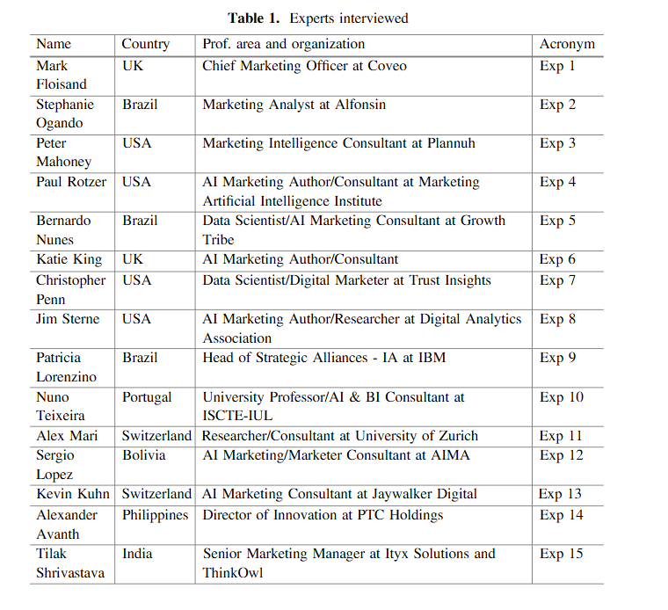

3.2 Generative Artificial Intelligence: A Systematic Review and Applications
Authors: Sandeep Singh Sengar, Affan Bin Hasan, Sanjay Kumar, Fiona Carroll
Published: March 2024

3.2.1 Problem Identified
The paper reviews advancements in Generative AI models like GANs, Transformers, VAEs, and Diffusion Models with an emphasis on their applications and ethical considerations.

3.2.2 Dataset
It uses datasets like ImageNet, CelebA, and MIMIC for images; Kinetics and VoxCeleb for videos; and CoNLL-2003, DUC-2002, and XNLI for NLP, putting an emphasis on ethical use of data.

3.2.3 Methodology

From 2012 to 2023, a systematic review was carried out that utilized standardized metrics like FID (images) and ROUGE (text) to analyze model architectures and applications.

3.2.4 Results
Swin Transformers and UVCGANs were more effective than other models in completing image tasks; MViTv2 achieved 86.1% of video classification. NLP tasks were proficiently carried out by GPT, BERT and ChatGPT, while synthetic data creation was improved by generative models.

3.2.5 Future Scope
In the future, research will concentrate on ethical AI principles and their scaling, as well as cross-modal tasks like combining text to images and domain-specific applications such as education and molecular synthesis.

3.3 Optimizing Contextual Advertising With Large Language Models: A Unified Approach To Ad Content Generation And Targeting.
Authors: Lav Kumar Salesforce Inc., USA ; Karan Khanna Netflix, USA
Date: January-June 2024

3.3.1 Problem Solved

This paper also encompasses a new approach called Contextual Ad Generation and Targeting (CAGT), which depends on LLMs for generating ad content, while optimizing keyword targeting in one single framework. CAGT integrates the process of ad content generation with keyword targeting in one single process to ensure proper alignment between the generated ad text and the targeted keywords to enhance the performance of an ad.

3.3.2 Dataset

To test the performance of CAGT, large-scale experiments were conducted over data from a prominent e-commerce leader. The dataset holds about 10 million impressions in ads along with other accompanying user information, content related to ads, relevant target keywords, and various other performance metrics, including, but not limited to CTR and CR.

3.3.3 Methodology

The CAGT framework consists of three fundamental components:
1) Adaptive Prompt Engineering
2) LLM-based Ad Generation, and
3) Reinforcement Learning-based Feedback Loop,
These components generate relevant and effective ad content while constantly optimizing the targeting strategy with feedback from the users.
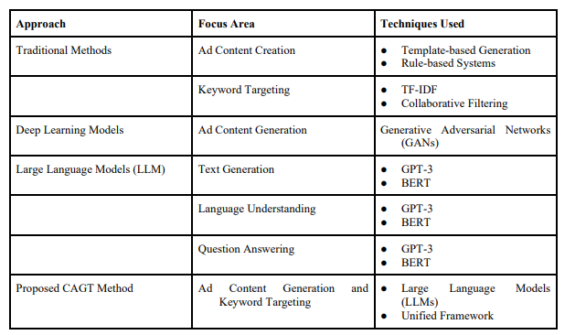Comparing CAGT with Traditional and Deep Learning Approaches

3.3.4 Results

The results are shown in terms of CTR, CR, and relevance score for all baseline methods and CAGT. For instance, CAGT gains 23% improvement in terms of CTR and 18% in terms of CR compared to the best-performing baseline method, LL based Ad Generation.
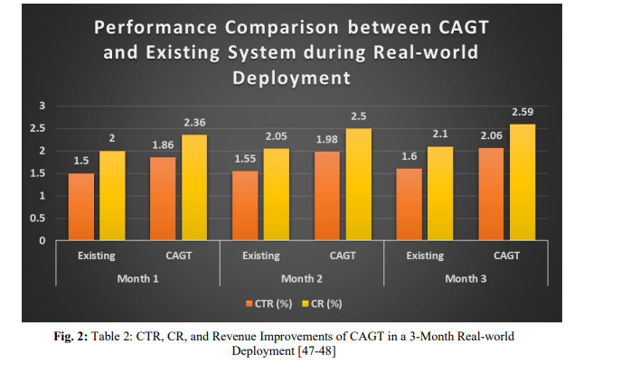
CAGT vs Existing System in Real-world Deployment

3.3.5 Future work

Future research directions might focus on the integration of multimodal information, for instance images and videos into generating ads. Another domain CAGT could be used in is social media advertising and email marketing. Both areas can be explored in depth and may give some insightful value to take forward this line of work.

3.4 Automated Model Selection For Time Series Anomaly Detection

Authors: Yuanxiang Ying, Juanyong Duan, Chunlei Wang, Yujing Wang, Congrui Huang, Bixiong Xu

3.4.1 Problem Addressed

The issue concerns time-series anomaly detection where diverse and noisy data make it possible for training supervised models due to shortage of labels. Automated model selection framework has been proposed to find the models fit for incoming data along with a custom tuning algorithm for filtering anomalies. This is fitting in new detectors, and also meets specific client requirements.

3.4.2 Datasets used

Time-series dataset, TSD, divided into a 3:1 ratio for training and testing. For each anomaly-increasing detector MiM_iMi​, a set of candidate parameters is evaluated, and the best performing pair is used, according to the F1 score, as the ground truth for the model selector and parameter estimator.

3.4.3 Methodology

The methodology involves feature extraction using transformations, including Spectral Residual and FFT; automatic model selection to classify and select the best anomaly detection model with optimized parameters; and a customized tuning phase to refine the detection results on user-defined criteria.

3.4.4 Results

This result shows that Auto-Selector will outperform individual anomaly detection models in most cases by effectively selecting suitable models and parameters leading to significant improvements of F1 scores and optimization in performance in various data series.

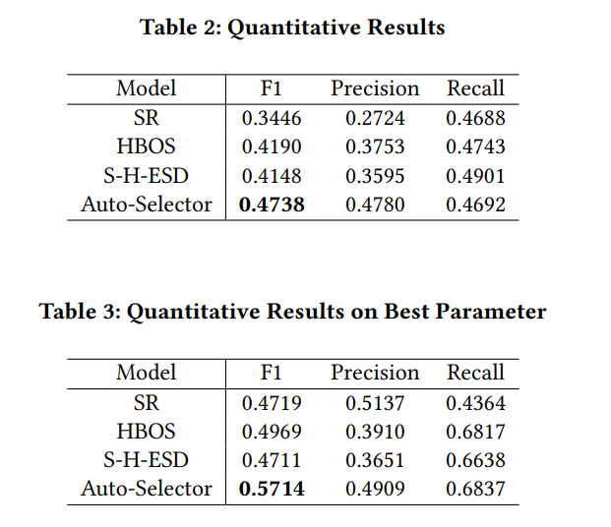

3.4.5 Future Scope

Improving the efficiency and accuracy of automated model-selection system, making systems less dependent on labeled data, and developing even more adaptable parameter estimation methodology. All these will lead to the development of a more robust, scalable, and effective time-series anomaly detection system in different industrial setups.

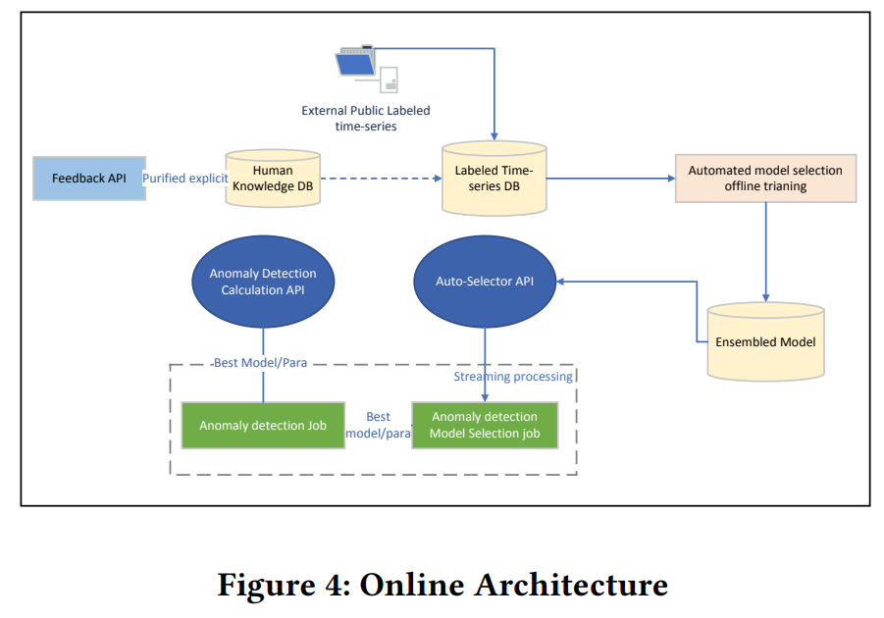

3.5 Generative Ai In Innovation And Marketing Processes: A Roadmap Of Research Opportunities
Published in Springer
Authors: Paola Cillo and Gaia Rubera
Year of publishing:2024

3.5.1 Problem Addressed

What are the research possibilities that come generative AI in the marketing domain.

3.5.2 Dataset

Feedback and inputs got from the people gen-ai in marketing will affect gathered and analysed.

3.5.3 Methodology

Surveys conducted with people belonging to the field.Thus a proactive approach leading to an accurate collection of data ,obtained directly from experts in marketing is obtained.

3.5.4 Results

Narrows down to few areas of growth and research in the domain like:
- What market research can be conducted with GenAI rather than human participants or experts?
- How can firms vary LLM parameters to create more persuasive messages? Which LLM parameter is most conducive to different marketing goals?

3.5.5 Future works

- Effective prompt strategy
- how firms can balance the advantage of supplementing their proprietary data to fully harness GenAI potential
- which firms can benefit the most from fine-tuning as well as which firms should instead exercise caution in doing so.

3.6 The Role Of Artificial Intelligence In Modern Marketing: A Review Of Current Technologies, Applications, And Challenges
Year of Publication : August 2024
Authors : Shardul Marathe

3.6.1 Problem Addressed

Impact of AI in modern marketing, with focus on current technologies, applications and challenges.

3.6.2 Dataset

Articles from 2013 to 2024 were examined using the electronic database Google Scholar, using specific keywords in the searches.

3.6.3 Methodology

Explored only long articles and journals on Google Scholar, filtered only the articles with involvement with the paper's title and abstracts, and narrowed the papers down using some criterion.

3.6.4 Results
It narrows down how AI is transforming modern marketing strategies like:-
1. How AI-driven technologies revolutionize content creation, targeting customers, and pricing strategies?
2. Considering the advantages, what are the challenges that underscore the necessity of businesses to adopt AI with caution, practicing ethics and robust data management?

3.6.5 Future works

1. How the transition from traditional marketing to AI-based marketing will happen from an economic, societal, and political point of view.
2. Analyzing fully AI-based companies versus traditional companies and seeing every metric from click rates to customer retention.
3.Internal Biases and how AI will deal with it; what policies can manifest in response to copyright and ethical concerns.

3.7 Deep Learning for Anomaly Detection: A Review

Authors:Guansong Pang,Chunhua Shen, Longbing Cao, Anton Van den Hengel

3.7.1 Problem Addressed

Anomaly detection can refer to the practice or act of inappropriate analysis, finding individual data points or sets of data points that deviate in a significant way from the majority of data. It has applications in many fields such as risk management, security, license, and healthcare. Deep anomaly detection does work better than the existing methods because it learns feature representations or anomaly scores; therefore, this is because it dominates the area in finding anomalies in complex, high-dimensional, temporal, and spatial data.

3.7.2 Dataset

A collection of real-world dataset containing natural anomalies in different modes and with different types of publicly available methods.

3.7.3 Methodology

Deep anomaly detection required feature extraction through models like autoencoders and GANs, learning representations of normality through self-supervised classification, and end-to-end anomaly scoring techniques like one-class classification. It addresses very important issues, those regarding data representation and scoring optimization.

3.7.4 Results

The results describe 12 deep learning methods for anomaly detection and have provided an explanation of 30 algorithms characteristics such as data augmentation and pre-training. These findings demonstrate a shift in deep anomaly detection that attempts to resolve simple challenges across applications.

3.7.5 Future works

Future work includes studying robustness to imbalanced and unlabeled data; enhanced interpretability of the model; efficient algorithms for larger data. Moreover, extending the evaluation metrics beyond the traditional performance measures would also be important

CHAPTER 4
RESEARCH/TECHNOLOGY GAPS AND CHALLENGES

- A link between how to connect sales dips to enhancing product marketing through advertisement is a bridge that has not been researched on a lot.
As two separate frameworks ,anomaly detection and gen-ai have been discussed often,but a potential problem-solution approach to the same is what can undergo more research.

- Contextual based advertising using LLMs is a commonly used approach for ad text content generation .However using those to integrate with GAN models for static image based advertisements in not widely explored

- Improving model interpretability for anomaly detection and model adaptation across the various product categories remains a challenge. More research is needed on how to better deal with unlabeled and unbalanced datasets and how to expand the evaluation metrics used beyond performance indicators such as the F1 score.

CHAPTER 5
OBJECTIVES

5.1 The primary identified objectives of the project are as follows:

- Analyse authentic sales data of the companies identified in the obtained dataset.

- Use graphical as well as machine learning based approaches to identify anomalies in the data,which being a ‘not usual behavior’ of product would most likely conclude to be a product with potential but not reaching the target audience in the most appropriate ways.

- Understand the marketing requirements and building of a prompt driven gen-ai based image advertisement generator for the product suitable for increasing its reach.
This could help combat the anomaly in the sales for the product.

- Refining of the model based on obtained performance parameters to suit the model better to the needs.

CHAPTER 6
DATA EXPLORATION

6.1 Overview
The project will be aimed at utilizing sales data to give some actionable suggestions that could help businesses to make better decisions, especially in terms of formulating targeted marketing strategies. The sales data will, therefore, be collected from varied sources and utilized with time series analysis to detect patterns and trends. Anomaly detection can determine the time boundaries for when sales moved out of the norm boundaries. Such anomalies may signal underlying issues, such as a product's performance drop or external market forces affecting sales. Another will include GenAI which will have a very significant application in forming targeted marketing solutions including personalized advertisements to cater to the area of intervention related to improvement of sales and optimization of business strategies.
Data exploration: understanding the structure of data, processing it, then exploratory data analysis (EDA) which brings out trends, anomalies, and a variety of relationships between the features.
The exploration of the datasets led us to find the Amazon product dataset, which gives an understanding of consumer behavior, performance characteristics of the products, and other exogenous factors that drive sales. This dataset will be analyzed for sales anomalies, pattern mining, and personalized advertisements to recover from reduced sales and optimize business directions. Further, datasets will also be culled from other sources, considering the trends indicated therein regarding seasonal buying nature, popular product categories, and the effects of events like holidays or global disturbances on sales.

6.2 Dataset
Amazon Product Dataset: The dataset consists of over 1000 ratings and reviews of products available at Amazon. Features are intended to give information on product characteristics and customer responses as follows:
product_id: Unique ID for each product.
product_name: Name of product.
category: Product category (electronics, clothing etc).
discounted_price: Price after all possible discounts.
actual_price: Original price before discounts.
discount_percentage: Percentage discount given on product.
rating: Mean rating by customers.
rating_count: Number of users having rated such products.
about_product: Short description on product.
user_id: ID of the user who wrote the review.
user_name: Name of the user who wrote the review.
review_id: Unique ID for each review.
review_title: Short title summarizing the review.
review_content: Full text of the review.
img_link: Image link of the product corresponding to it.
product_link: Link of the product on Amazon's site.
What we can infer from this dataset:
The opportunities to highlight anomaly detection, i.e. deviation from expected behavior, are well described in the Amazon Product Dataset. Anomalies in this description are as follows:
Rating Anomalies: Sudden sharp increases or decreases in product ratings with respect to other equivalent products average could mean potential quality problems or gaming activities.
Review Anomalies: Sudden surges or reductions in the amount of reviews, most likely the result of promotion, fake reviews, or customers reacting spontaneously.
Pricing Anomalies: Irregular price changes or steep discounts too far away from the norm according to pricing patterns.
Sentiment Anomalies: Sudden peaks in the sentiment of reviews on products compared to product reviews that are well rated with sudden drops in rating.
CHAPTER 7
CONCLUSION OF CAPSTONE PROJECT PHASE - 1

The initial stage of our initiative has provided a solid foundation for generating advertisements based on sales anomalies.

During this period, our focus was on analyzing sales data, examining various models for sales anomaly detection, and exploring GenAI as a tool for advertising production.

We reviewed the literature, concentrating on recent advancements in Generative AI and machine learning models. We also explored the use of LLMs to create ad content and how automated model selection can be applied to detect anomalies.

These steps have provided us with a strong foundation to move forward with the implementation in the next stage.

CHAPTER 8
PLAN OF WORK FOR CAPSTONE PROJECT PHASE - 2

8.1 Implementation of Anomaly Detection
  - Use statistical models, machine learning algorithms, or thresholds to identify anomalies in sales data.
  - Explore automated model selection frameworks for detecting anomalies more efficiently across diverse datasets.
8.2 Integration of Generative AI
  - Incorporate GenAI models (e.g., DALL·E for image generation) to create personalized ads addressing the detected anomalies to make sure that we concentrate advertising on underperforming items, increasing their exposure and addressing declines in sales.
8.3 System Development and Testing
  - Develop the system that incorporates both anomaly detection and Generative AI for ad generation
  - Test the system's accuracy, reliability, and performance by integrating real-time and historical sales data.

8.4 Data Collection and Refinement
  - Obtain multiple datasets for the purpose of training and testing out their syste

8.5 Evaluation and Optimization
  - Assess the impact of ads by analyzing click-through rates (CTR) and sales growth.
  - Build the system around performance analysis and stakeholder input.
CHAPTER 9
REFERENCES/BIBLIOGRAPHY
[1]https://www.researchgate.net/publication/341994540_Artificial_Intelligence_Applied_to_Digital_Marketing/

[2]Generative artificial intelligence: a systematic review and applications | Multimedia Tools and Applications

[3] https://link.springer.com/article/10.1007/s11747-024-01044-7

[4] https://arxiv.org/pdf/2009.04395

[5]https://www.researchgate.net/publication/382876702_The_Role_of_Artificial_Intelligence_in_Modern_Marketing_A_Review_of_Current_Technologies_Applications_and_Challenges

[5] https://www.sciencedirect.com/science/article/abs/pii/S0148296323004836

[7] https://arxiv.org/pdf/2007.02500



